EXP 11 K MANOJ KIRAAN

240701305

Create Portal User Using Zoho Creator

Aim
To create and configure a portal in Zoho Creator to provide external users with controlled access to the EviTrace application.

Procedure
- Open the EviTrace application in Zoho Creator.
- Navigate to Settings → Portal and configure the portal.
- Set the portal type and configure the portal URL.
- Set the default portal permission to Customer.
- Create a permission set named EviTrace_Portal_Viewer.
- Configure the permission set to provide the required viewing access to authorized application forms and reports.
- Add and manage portal users and assign the appropriate permissions.
- Open the portal using the portal URL and test user login and record submission.
- Verify that portal access and form operations work as expected.

Output

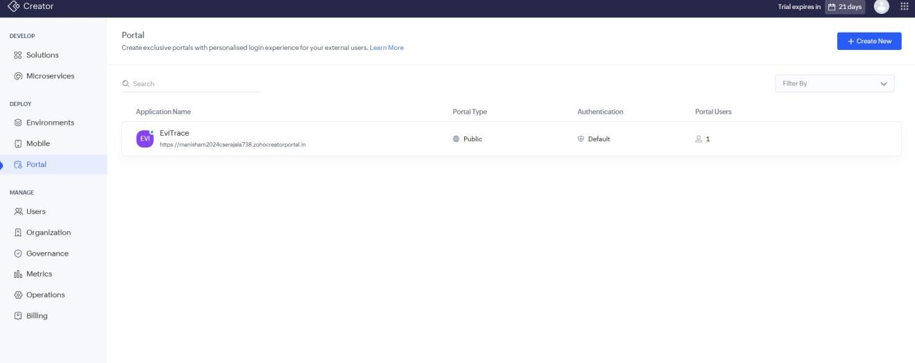

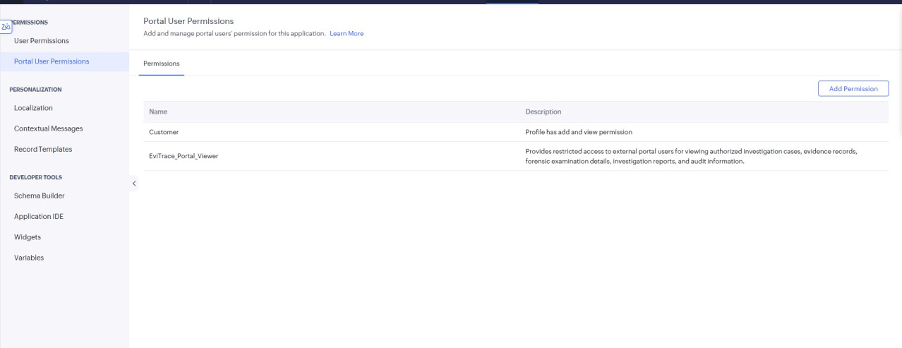
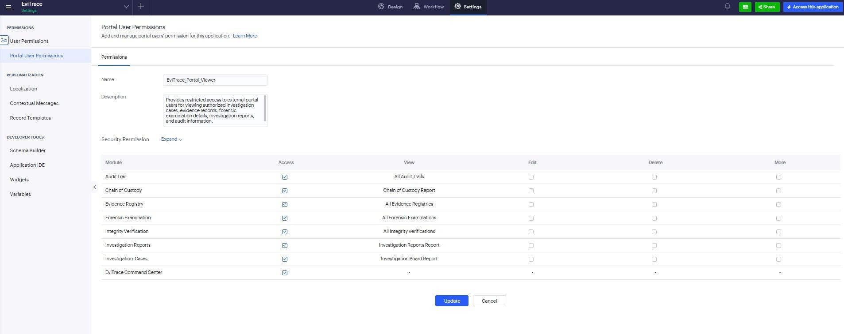

Result
The EviTrace portal was configured to provide external users with controlled access to the application using portal permissions.

